Monday  16th | *****No school Dr. Martin Luther King Jr. Day******  __Be sure to remember: “How special it is, we can be at a school together, knowing we are all humans-even with our differences.”__
Tuesday  17th | Word & letter work related to Words their way sound spell test  Comparing sets using more, less, and fewer terms  Readers use their letter sound awareness to read unknown words----no more guessing Use your powers to get the words  Writers keep writing many “How to books” & share with others
Wednesday  18th | Word & letter work related to the long vowel sounds –e-(tree)  *Welcome our newest pets---pill and sow bugs  Observations and comparing pill vs. sow bugs  Music and movement with Mrs. Sarah  Writers share their stories & ask for ideas  Who is Ruby Bridges? Weekly reader take home and discovery of “courage”  Identify, create, and compare same number of objects
Thursday  19th | Word & letter work related to long vowel sounds –i--ice  Jackie Robinson –Who what, when simulation as a community  Writers use ideas from others and make changes  *Bring in and share a Non-fiction storybook you are familiar with  Readers think about non-fiction/ vs. fiction storybooks  What is the difference between fiction and non-fiction???
Friday  20nd | ***All building paired grade morning meeting@ 10:25 all are invited  Word & letter work related to a long vowel sound sentence book  Writers publish a new “How to book” to take home  Readers use consonant clusters to solve unknown words  Reading buddies with TBD classroom cross grade connections-Showing our super reading powers off to others
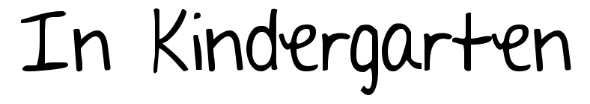

Jan. 17-20

Notes: ***Be sure to be checking in on your child’s take home yellow folder. I will be introducing an apple stamp that states…”please finish and return.” If you see this, it is because your child needs to complete the work due to being off task. I give a good amount of time to complete “must do goals.” You will also often see other partial completed goals. If they do not have this stamp, they were optional goals.
**Over the next several weeks we will be studying long /short sounds of the vowels. Be sure to watch for a vowel parade invitation. We will create costumes of our favorite hardest working vowel.
A learning goal I have for the week is:
I will be able to write all uppercase/lowercase letters on a line by myself. –triple lines advanced.
I will be able to explain 3-5 facts about Dr. King Jr., Ruby Bridges and Jackie Robinson.
I will be able to publish my newest “How to book” and take home to read with another.
I will be able to use the “peace rug” at school to solve small problems on my own regarding feelings being hurt.
I will be able to read near 10 or more sight words from our lists provided at conference/report card times.

