Monday  24th | Word and letter work related to Oo Olive Octopus discovery day  Music and movement with Mrs. Sarah  Readers have super powers!!  Writers read into the circle & share their writing  Counting 1:1 up to 10 objects and move between groups
Tuesday  25th | Word and letter work related to Oo Olive Octopus handwriting  Writers write in their new handwriting books… Add to our letter  Fun with estimation in Math & introduce number stories stage 1  **Pumpkin /Jack-o-lantern seed estimation activity & carving*  Readers use their powers and read everything they can  Writers write for readers to read
Wednesday  26th | Word and letter work related to Oo Olive Octopus Phonemic sounds  Music and movement with Mrs. Sarah  Super readers use point power to check their reading & make sure it matches  Acting out our story problems without equations  Make our writing everything it can be for readers
Thursday  27th | Word and letter work related to words we use… Focus words “The, is and red” We have also introduced A, at, in, I, it We will have 52 total sight words to focus on this year  Writers share their narrative “true stories” with writing partners  Order and count dotted cards up to 10
Friday  28th | Authors and Illustrators create a readable Oo sentence book  Making mathematical stairs 0-10 with cooperative partnerships  ***Be sure you note we will celebrate our Fall Festival downstairs. All are welcomed keeping costumes at home  Fall Festival –all are welcomed costume free day. Keep posted for times:::::  ***If you are taking your child home after this event, please stop back at the classroom for pick up. (when event is over)
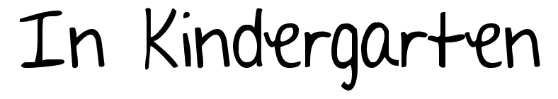
Oct. 24-28th

**Thank you VERY much for being part of our goal setting conferences! I look forward to the next few months of learning, before our next conference.
Notes:
Be sure you recognize our Friday Fall Festival is a non-costume day. It is a special time we can make connections with other grades and celebrate Fall time. You and your family are welcomed at this event. This event is put on by, “New City Circle.” If you would like to support/help out with this, please get in touch with school. Thank you for your continued connections via e-mail. I will continue to get back to you as soon as I can. Have a great day!
**If you need to reschedule your conference, please connect with me this week It is important to meet soon.
A learning goal I have for this week is:
- To recognize, write and say the letter Oo, Aa, Bb, Ff, Ii, Nn, Rr, Ss, Tt
- To read my sentence book to many people at home
- To READ/WRITE daily at home
- To use my super powers (ask them) in writing/reading at home.
- To count up to 10 and down from 10…..count a scattered amount of items 1:1 to 10
- Use my “Super powers” when reading

