Monday  14th | Word and letter work related to Qq and Zz  Queeny quail and Zeke the Zebra  Super readers learn “snap” words and remember them in a “snap” --focus on sight words—see handout Monday.  Music and movement with Mrs. Sarah  Module 2---2 dimensional and 3 dimensional shapes –Triangles today  Zz and Qq trace & cut Art craft
Tuesday  15th | Writers create a Qq & Zz word sentence book for take home  Word and letter work related to Qq & Zz handwriting  **Report card assessments**  Focus on Rectangles today  Writers use word wall words in their writing  Snail body parts continued….label and start -class animal book  ***INTRODUCE our “Peace Rug” Problem solving technique
Wednesday  16th | Word and letter work related to handwriting with our letters inside words  Writers use “sneaky ninjas” (vowels) in their words  Focus on hexagons and circles today  **Report card assessments**  Music and movement with Mrs. Sarah
Thursday  17th | Word and letter work related to the “On” word family and new word wall words “The, you, and me”  **Report card assessments**  Focus on positions of flat shapes today  Readers celebrate their powers! Be ready to celebrate with others in our school!! WAY TO GO READERS!!!
Friday  18th | Word & letter work related to creating a readable Qq & Zz word book. Be sure to add additions and read to many friends at home.  All school morning meeting mixed grades in each building  Readers use double powers with reading partners  Focus on solid shapes today  ***Bring in and share something for a shape museum today. Be sure you are ready to explain what shape it is, and characteristics of the shape. This can be a picture, item, or something you think about
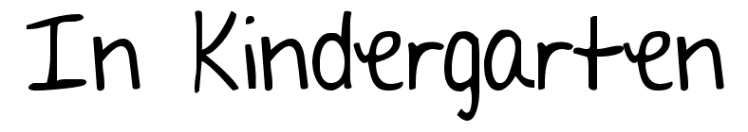
November 14-18
Notes: We continue to go outside 1- 2 times a day throughout the winter season. It is VERY important to have warm (LABELED with name) clothing for your child here. After Thanksgiving break will be looking at 2 of the 5 weekdays being spent inside downstairs. This will only be the before lunch recess only. They will always go out towards the end of day. We will go through a bowling and basketball unit this winter. Thanks!
I will also start “Check out books” this week. I will have about 6-8 book bags filled with leveled readers. If you would like to check them out, please send “book check out” by the day you sign above. I will do my best to send home that day. If they are all checked out, I will let your child know. Have a super weekend!! Mr. JEREMY

A few learning goals I have this week are…
- Read, Read, listen to a reader, Read, Read Tell others about what you read and reflect on how you would change it.
- Continue to practice counting, and writing on a daily basis
- Tell others how you feel –focus on expressing needs towards others with “I statements”
- Know how to use the “peace rug” and listen to others feelings when it is being used
- Explain many shapes and give facts about them…points, sides, corners and more
- Know several parts of a pond snail

