Monday  7th | Word and Letter work related to Cc & Mm Catina Cat & Missy Mouse  Let’s discover where to find Cc/Mm & How they look in print  Music and movement with Mrs. Sarah  Human adaptation with the seasons day 1  Arranging number towers in order from 10-1
Tuesday  8th | Word and letter work related to handwriting with Cc/Mm  C-push up touch, around to bottom and back up  c- push up touch the dotted line, around to bottom and back up  M-Start at top, pull down, lift up to top, pull down right, push up and down to bottom  m- start at middle, pull down, push up, around down, up, and down  Human adaptation with the seasons day 2  Arrange, analyze and draw sequences of qualities 1 less than shown
Wednesday  9th | Word & letter work related to word fence words & past word families  Writers add more details to pictures and stories with our writing  Music and movement with Mrs. Sarah  RE-welcome our newest animal friends- “Pond Snails” We observe as scientists  ***Bring in and share a toy you remember enjoying as a younger child/if possible as a toddler.  Classifying objects of a bag into two groups
Thursday  10th | Word & letter work related to phonics with Cc/Mm  Pond snail craft including labeling parts  Writers continue to stretch their words using “arm” method focus on the syllables in the words  **Bring in and share a Cc/Mm item, word, picture day**  ****Picture Re-take day for those missed ****  End of module 1 assessment
Friday  11th | All school morning meetings –paired meetings K-5  Word & letter work related to “My Cc/Mm word book”  Writers use strategies to make my writing the best #3 quality  Partnership reading buddies with TBD grade level  End of module 1 assessment
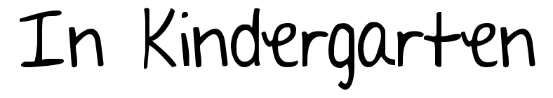
Nov. 7-11th

Notes:
Be sure to continue sending warm clothing each day. We go outside two times a day. It is also BEST to label your child’s winter clothing. We will have many similar items. This weeks Wednesday folder has a special (upcoming dates) notice from the office.
A learning goal I have for this week is:
- To recognize, write and know the sound of Aa, Cc, Ff, Gg, Hh, Ii, Jj, Ll, Mm, Nn, Oo, Rr, Ss, Tt
- Explain several facts about a pond snail
- Read my C/M readable sentence book to 3-5 people and add -more if I wish
- Use first letters in my sound spelled words when writing
- Use my “arm method” when sounding out word parts. This helps with beginning/middle/ending sounds
- Read/write several at, an, and now in word family words. Example--- Pat, Fan, Tin

