Monday  5th | Word & letter work- Dd & Vv Dee-Dee Deer & Vincent vampire bat  Writers continue revising and using all they know  Readers continue to focus on re-telling parts of story  Music and movement with Mrs. Sarah  Comparing length measurements with a string  Continue thinking about keeping my body healthy/exercise plans
Tuesday  6th | Word & letter work related to Dd/Vv handwriting  D-Start at top, pull down, lift up, out and around down  d-Circle around, push up to top, and pull down  V-start at top, pull down right, push up to top right  v-start at dotted line, pull down right, push up to dotted to right  Make a series of longer than and shorter than comparisons  Writers use feelings to end their stories
Wednesday  7th | Word & letter work related to the “ing” word family  Readers retell parts of a story we have read in class “Gingerbread Baby”  Music and movement with Mrs. Sarah  Writers make their pieces beautiful to get ready for publication  More focus on holidays around the world  Compare the length of lining cube sticks to a 5 stick
Thursday  8th | Word & letter work related to phonic fun with Dd/Vv  Symmetry with snowflakes---make /display /take home  Readers re-tell stories to themselves.  Writers think about our classroom rubric, when writing-use/and take home for future usage  Determine which is longer and shorter and why?
Friday  9th | All school morning meeting at 10:20-10:40 all are invited  Word & letter work related to Dd/Vv word books  Future hot chocolate social voting- We will vote in what class to have social with. You are invited this happens next Friday 16th See below  Comparing length with various classroom objects  Writers celebrate: brining true stories to life!
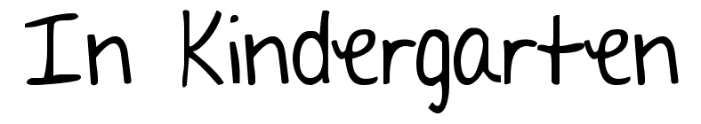
Dec. 5-9th
Day for book check out.

Notes:
We continue to discover word families and how to make them into words. Be sure you continue to help your child with these words. When reading/listening to books at home, think of the following when asking your child to re-tell the story. This includes beginning, middle and ending. You may also ask specific questions regarding character connections. Close the book and tell me about what happened.
- Remember to start at the beginning. Tell me about the first/middle and last parts
- Who was in the book? Characters?
- What do you think would happen next? or if you were the author what would you say?
**We will be having a hot chocolate social on Friday December 16th. All are invited This will take place at 3:45-4:15.

A learning goal I have this week is….
- To read, write, and recognize the sound of Dd& Vv plus many other alphabet letters
- To continue to focus on thinking about what numbers come before and after a specific digit
- Read and recognize 5 or more common color words—see your list from report cards
- Tell several facts about pond snails and how to care for them
- Explain several facts about solid and flat shapes. Be specific about points, sides and corners
- To make & read several “ing” word family words.

