Monday  13th | Word & letter work related to “Words Their Way”  Readers read their books and share detail with the class  Writers add to/finalize their current “how to” books & prepare for option choice of entering the “literary Magazine” this spring.  Introduction/reviews of the penny & now nickel  Who is Abraham Lincoln? George Washington?  Abraham Lincoln craft project day 1  Presenting and illustrating number bonds  Choosing my Vowel animal of choice for upcoming parade
Tuesday  14th | Word & letter work related to kind words  **Wear Red, White, Pink day** optional  Celebration with Valentines Day * share/ pass our our classroom made Valentines***If you want to bring in a snack, you may. If possible, limit the amount of high sugar items. When many things come in, it may get to be a lot of sugar Fruits are great
Wednesday  15th | Choose an animal to study for our “animal fact wall” This is a start to the next part of our animal thematic unit. It will be a research project we will all do. In the end, we will present information to all families.  More with number bonds & decomposing /illustrating them  Writers continue how to books about things they learn from our day  Word & letter work related to our sight words  Vowel animal mask creations---Day 1 of 2
Thursday  16th | Word & letter work related to sorting multiple times & gluing  *Readers be sure to make book exchanges when books have been read 6 or more times. Remember-good strong readers, read their books more than 1 time! In class we read 6 or more times.  Abraham Lincoln craft project continued  Writers be sure they have “what you need” page before step one  Finish vowel animal mask & or start creating the body of costume
Friday  17th | *****No school staff development day****
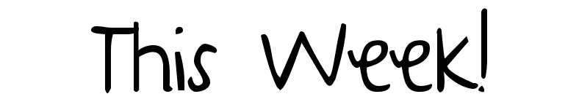
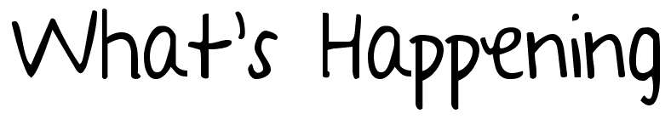
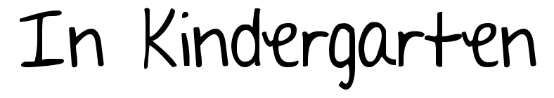
Feb. 13-17th

Notes:
-Reminder **Feb. 24 we will have our vowel parade. Please see student made invitations this week.
-Thank you all for a super special conference session! I appreciate seeing and sharing with you all. If you have any further questions, please get in touch. 612-623-3309 or Jeremy@newcitycharterschool.org thanks!
-Over the next few months we will be taking a deeper close look at “Words Their Way.” This is our newest step to word work. We will be sorting and thinking about many words and even some with blends. Each picture/word sort will be connected to the current level your child is performing at. When they come home on Thursdays, be sure to review in anyway you can.
A few learning goals I have for this week are:
- To share my word sort with another person.
- To read my Friday take home book to another person.
- Explain what your “animal of choice” looks like. Including 3 facts about it.
- Read or listen to a story at home. Re-tell it from the start using names and specific information noted in the story. This is our “Re-tell” power. KEY TO MOVE ON IN OUR READING TESTING
- Explain several facts about two past presidents Abe/George….note what they did, and why important.

