Monday  8th | Word & letter work related to my personal word sorts  Writers continue writing letters to future Kindergartners  Music and movement with Mrs. Sarah  ***Bring in a favorite nursery rhyme to share. OR tell us about one  Using the Rekenrek and showing amounts with them.
Tuesday  9th | Word & letter work related to creating words we know  ***Stuffed animal share day….bring in a stuffed animal to read,  write and share with. Be sure it fits in your child’s backpack  *We will start writing letters to Mrs. Breanna’s Kindergartners  Show and count 11-20 in a tower and show increasing configurations
Wednesday  10th | Word & letter work related to sorting & gluing word sorts  Music and movement with Mrs. Sarah  ***Dress silly day---KG Mr. Jeremy ***  Writers write to other KG friends stating their opinions on ???  20-11 decreasing tower configurations  Wacky Math bingos as a whole group  Wacky take home hat project to complete our WACKY day :0
Thursday  11th | Word & letter work related to writing a letter to a teacher  **Classroom Library Trip Day---Return & check out books  Author find focus day!  Answer how many questions with linear and array configurations  Art as Steven Kellogg—focus on detail with our storybooks  Readers share their books with others. They focus on the five finger RE-TELL!
Friday  12th | All building morning meeting together. K-3 10:25-10:45  Writers share their papers with others… to make a change in our world  Reading buddies collaboration with another classroom---focus on re-tell  Additions to our classroom fictional storybook. In future…stop by to check it out  Math games using amounts up to 20 in circular configurations.  Music work share for grades 4-8 We walk to other campus and watch/listen.
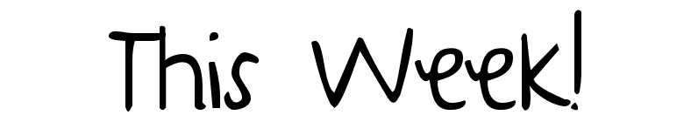
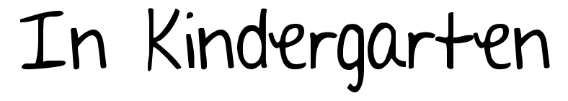
May 8-12th

Notes:
Upcoming Events: These will continue to be sent home in RED Wednesday folders for more information.
- May 19th Round up day for all students—try out your next year for 2 hours in am.
- May 20th Art-A-Whirl Saturday events at our school.
- May 29th No school-- Memorial Holiday
- June 8th 8th grade graduation
- June 9th Minnehaha Falls K-8 Trip
- June 14th last day & portfolio share.--Also Kindergarten graduation—all are welcomed! Located in Kg. Rooms. More information to follow.
All assessments will continue. Over the next few weeks I will gather information and put the final report card together. You will receive it on the final day during our KG graduation ceremony. Be sure to have a water bottle here at school! These last several weeks will get warm, and we are very thirsty throughout the day. It is quicker to grab a drink in the room vs. going down the hall to the water fountain.

