Monday  10th | Word & letter work related to Ff Francy Fish & Nn Nigel Night-owl  Music and movement with Mrs. Sarah  Please welcome our newest animals---guppies & goldfish  Writers stretch out words to find the letter sounds  Sets of 7 in scattered configurations/ write 0-7  Readers continue to point to words they read
Tuesday  11th | Word & letter work related to Ff & Nn- Handwriting  Readers are brave when they get to hard words-focus on sounding  What is a toddler? How are they different from a baby?  Writers think about details with their writing-focus on sounding  Compare and counts in linear and array configurations
Wednesday  12th | Word & letter work related to “ar” word families  Music and movement with Mrs. Sarah  Readers reread old favorites -remember to say more and more  Writers add more details to pictures and stories  Up to 8 in scattered configurations & 0-8 writing
Thursday  13th | Word & letter work related to phonics/sounds with Ff & Nn  Toddlers on the run… how to they move & changes in their dev.  Writers write letters to their teacher  Readers ask themselves questions about what they are reading  How do the goldfish and guppies get along? Body parts? Diff/sim  Organize & count to 9 with varied geometric shapes in linear & array
Friday  14th | All building morning meeting in City Center- All are invited 10:25-  Word & letter work related to “My Ff & Nn Word Book” creations  Readers celebrate reading old favorites & share with partners  ***Bring in and share a favorite storybook part 2—this may be one you have memorized, reading on own, or can picture read  Reading buddies with TBD classroom  Writers write letters to their writing partners
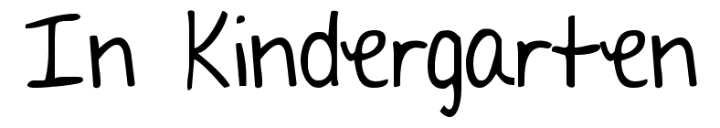
Oct. 10-14th

Notes:
We will start thinking about differences in guppies (our newest animal) and our goldfish. If you need help scheduling goal conferences online, please let me know. Thanks! Cooler weather is right around the corner. My recommendation is that all children bring out their coats daily, and can take off if they get hot. We make the verbal connection, with how we need to “protect” our bodies. Have a great week!!
A learning goal I have for this week is:
- To recognize, write and say the sound of Ff & Nn letters and others we have practiced
- To write many “ar” word family words on my own
- To read my Friday word book to others at home 4 or more times
- To explain facts about a toddler & characteristics that make it different from a baby
- To CONTINUE to sound out words in both reading & writing---stretching our words
- Write numerals 0-9 on a line with no guidance.
- Count 1:1 an amount up to 9 pointing or moving each object while counting them.
- To celebrate reading!! WE ARE ALL READERS! Find things you can point at, and read with families.

