Monday  27th | Word & letter work related to new word sorts  Music and movement with Mrs. Sarah  Writers more labels their diagrams to teach more information  Readers think about a book they want to present & give facts/opinions to others  My animal illustration activity---part 1 to animal fact wall
Tuesday  28th | Word & letter work related to word sorting initial/final & blend sounds  Animal fact wall part 2  Readers continue to find connections they have with books  Writers conference with partners for revising
Wednesday  1st | Word & letter work related to sorting our word sorts  Music and movement with Mrs. Sarah  My animal’s habitat---illustrate/write for the “animal fact wall”  Writers think about adding final detail to a current “How to Book”
Thursday  2nd | Word & letter work related to Dr. Seuss **Birthday**  ***food sample---REAL green eggs and ham tasting! OPTIONAL  Word & letter work related to word sorts blends and more-gluing  ***Read Across America Day** All before lunch/ K-3 reading buddy & possible author visitor. Bring in favorite books (with names on them) pajama/cozy clothing, blanket & flashlight…all optional**  Animal habitat part 1 –“the forest”  Readers present their stories to another. Give facts and  Writers share their “How to books” with others
Friday  3rd | Word & letter work related to using our blends in sentences/book  All school morning meetings-all are invited  Animal habitat part 3—“the water” if time permits---due to options  Option classes day 2 of 5 3:45-4:30
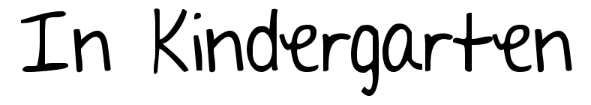
Feb27- March 3

Notes:
On March 17th K-8 will be sending home report cards. Please look for them in a small envelope. It is important to sign the envelope and return it.
Each student has started the study of a Minnesota animal. They will choose their animal early this week. Be sure to stop by, over the next few weeks. You may see their information collected on the “animal fact wall.” We will give a presentation just after spring break. Have a great weekend!
A few learning goals I have for this week are:
- To read my word sort or blend book many times. Add to it if you have a chance.
- To tell others about number bonds using number amounts 5-9, as a whole
- To practice my personal address & phone number!!
- To write my first and last name MANY times on a line, on my own. WE have been getting many capital letters after the first letter. Lowercase letters are very important
- To practice my sight words from lists given out at conferences.
- Read my “how to books” to many people at home.

