Monday  24th | Word & letter work related to NEW GROUPING personal word sorts  Music and movement with Mrs. Sarah presentation practice  Finish 3/D worms and observational drawings of our live worms  “A Fish is A Fish” shared reading and fish creation/decorating  Storybook work mat using characters/beginning/middle/end  For an organization tool  Module 6 Counting sticks/straws into piles of ten.  Preparing our “Teachable Math” projects—WE will be the teachers!
Tuesday  25th | Word & letter work related to making a classroom fictional storybook  LIBRARY WALK---bring your library cards for check out opportunities. We will focus on locating fiction vs. nonfiction ---This will change to Thursdays 1:25-2:30 for the remainder part of the year!  **I cannot get your child a library card, Sorry you will need to stop by to fill one out. All friends will have opportunities to look and explore with books!  Sun/light study --natural and artificial light activity  10 ones and _____ones are
Wednesday  26th | Word & letter work related to classroom fictional storybook  Music and movement with Mrs. Sarah presentation practice  Good strong readers make connections and think about what is next with their readings  Teachable Math project finalizations /lesson 4 counting straws the ten way to 19
Thursday  27th | *Special Guest Hennepin County Recycling person—2:00-2:20 Recycling works  Word & letter work related to word scrambles. Making a words with letters I can find.  Readers share their stories with other students. This process is used to focus on the re-tell. I will be starting our reading assessments soon! One big part of the testing is remembering to provide detail to your re-tell!! Remember---Beginning, middle, middle, middle, end with character names and detail
Friday  28th | Regular morning meeting today with your community  Creating our word sort book. Use our past personal sort words to create a readable storybook.  Other invertebrate animals…..what and where/habitat?  Using 10 & 20 in number bonds
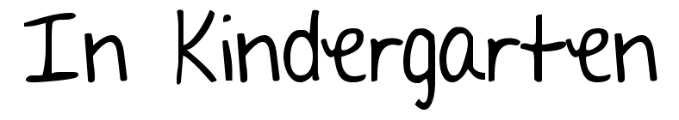
April 24-April 28th

Notes:
Please notice as the year continues to come to a closure, It’s VERY important your child is demonstrating safe and in control behavior. During walking and bus field trips this is EXPECIALLY important! We will continue to walk to the library each week. If you want your child to check out books, please send in a library card with them. I cannot check out for them. Testing and assessments will continue to happen the last few months Be sure your child has a water container/bottle here each day. I will be sending them home on Fridays for washing Thanks!
We have our music work-share and our KG Teachable Math projects on Friday May 5th. The times are 2:35-3:00ish KG Mr. JEREMY Math presentation/projects and then following at 3:30-4:30 K-3 Music work-share concert.
A few learning goals I have for this week:
- Be able to create and solve single digit addition and subtraction problems. These include number sentences and number bonds to match them.
- Be able to create a readable “word sort” book.
- Know my phone number and address with little to no guidance
- Create a word with letters given…CVC word and others
- Explain several facts about worms.
- READ –RETELL- READ –RETELL –READ –RETELL

